Handbook: Configuration Guide for UpdateTableBasedOnColumnValueGeneric
This handbook explains the required files, directory placement, and configuration steps needed to successfully use the UpdateTableBasedOnColumnValueGeneric flow within the TDM_TableLevel LU.

1. Required Files to Upload
Below are the two mandatory files:

1. UpdateTableBasedOnColumnValueGeneric.flow
- Upload this file to: TDM_TableLevel LU → Broadway directory
- In the TableLevleDefinitions.csv, update the load_flow column with this flow name for the specific interface, schema, and table.
- 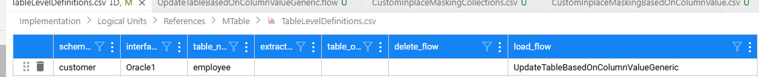

2. UpdateTableBasedOnColumnValueGeneric.csv
- Upload this file to: References → Mtable directory

2. Configuring UpdateTableBasedOnColumnValueGeneric.csv
This file contains essential mapping information required for column-level masking based on a key column.
Below are the column headers and their purpose:

Column Definitions

1. InterfaceName
- Represents the interface name of the masking table.

2. SchemaName
- The schema name where the masking table exists.

3. TableName
- The table name on which masking should be applied.

4. KeyColumn
- The column based on which masking should occur.
- Example:
  - If FIRST_NAME is masked based on CUSTOMER_ID, then:
    - KeyColumn = CUSTOMER_ID

5. ColumnToUpdate
- The specific column that needs to be masked.
- Example:
  - If FIRST_NAME is being masked, then:
    - ColumnToUpdate = FIRST_NAME

6. MaskingID
- Logical identifier used to maintain consistency across rows.
- Suggested: use a single logical name for each masking operation.

7. Collections
- Represents the list of masking values.
- Values should be maintained in your masking collections repository.

